BSDA2001P: Introduction to DL and GenAI Project
Smart MCQ Solver Challenge — Project Report
Roll No: 24F3004524 | Kaggle Competition: smart-mcq-solver-challenge | W&B Project: 24f3004524-t22026

1. Abstract / Executive Summary
This project addresses the Kaggle “Smart MCQ Solver Challenge,” a five-option multiple-choice question-answering task spanning varied academic domains. Each question provides a short prompt and five candidate options (A–E); the model must rank up to three candidate letters, and submissions are scored with Mean Average Precision at 3
Three architecturally distinct models were built and tracked under a single Weights & Biases (W&B) project:
(1) a from-scratch hybrid BiLSTM + Transformer-encoder classifier,
(2) a fine-tuned microsoft/deberta-v3-base multiple-choice transformer, and
(3) a TF-IDF + Logistic Regression baseline.
All three share the same stratified train/validation split are evaluated with accuracy, macro-F1 and MAP@3. On the held-out validation split, the TF-IDF + Logistic Regression baseline reached 97.25% accuracy (MAP@3 = 0.9804), and the scratch hybrid model converged to a validation MAP@3 of 1.0 by epoch 4 of 5. Key learnings include the importance of MAP@3-aware evaluation over plain accuracy, the practical trade-offs between classical and deep-learning approaches on a small training set, and the combination of techniques needed to fine-tune a full transformer under limited GPU memory.

2. Introduction

2.1 Problem Statement
The Kaggle competition “Smart MCQ Solver Challenge” provides train.csv (2,000 rows × 8 columns: id, prompt, A, B, C, D, E, answer) and test.csv (500 rows × 7 columns, without the answer column). Each row is a single multiple-choice question; the task is to predict, for every test question, a ranked list of up to three option letters most likely to be correct.

2.2 Project Objective
The objectives for this project were to: (a) build at least three unique models: one built from scratch, one pretrained, and one additional model of choice, (b) track every model with valid, comparable W&B runs using common metrics; (c) exceed the 0.73 Kaggle MAP@3 cutoff; and (d) document the methodology, comparative results and learnings clearly.

3. Dataset & Preprocessing

3.1 Dataset Description
The training set contains 2,000 questions and the test set 500 questions, each with a prompt and five options (A–E). Several prompts share the same underlying fact but are phrased with different instructional templates (“Pick the best possible answer:”, “Determine the correct option:”, “Select the most accurate option:”, “Identify the correct statement:”), suggesting the dataset was generated from a smaller set of base facts using templated rewordings.

3.2 Exploratory Data Analysis (EDA)
- Missing values: None. The function call: isnull().sum() returned zero for every column in train.csv.
- Class balance: The correct-answer letter (A–E) is reasonably balanced across the training set, which reduces the risk of a trivial “always predict the most frequent letter” shortcut.
- Prompt length: Prompts average ≈ 18.1 words with a maximum of 51 words, short, single-sentence questions well within the max_length settings used for tokenization.
- Answer-length-rank check: For each question, the five options were ranked by word count and the rank of the correct option was recorded. The resulting distribution across ranks 1–5 is not uniform, indicating the correct answer is oftentimes the longest option. It can be observed that usually by and large, the option most likely to be the correct option, happens to be the longest as well.

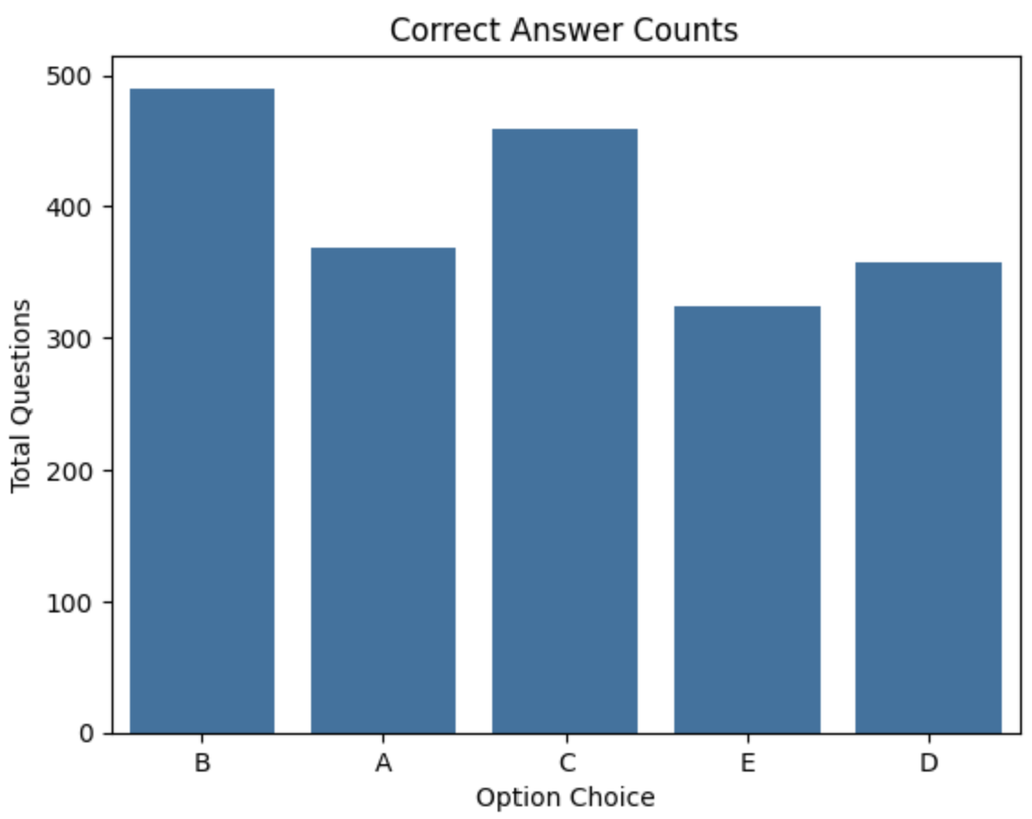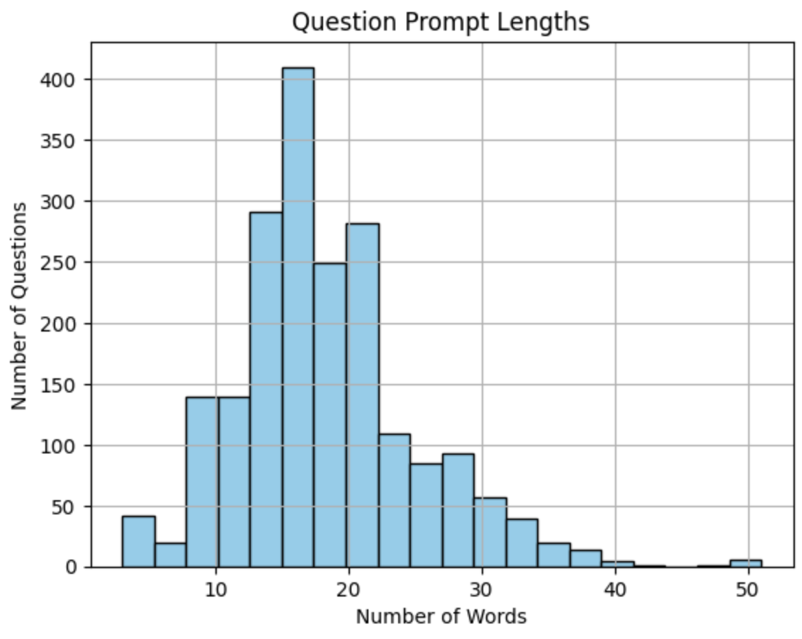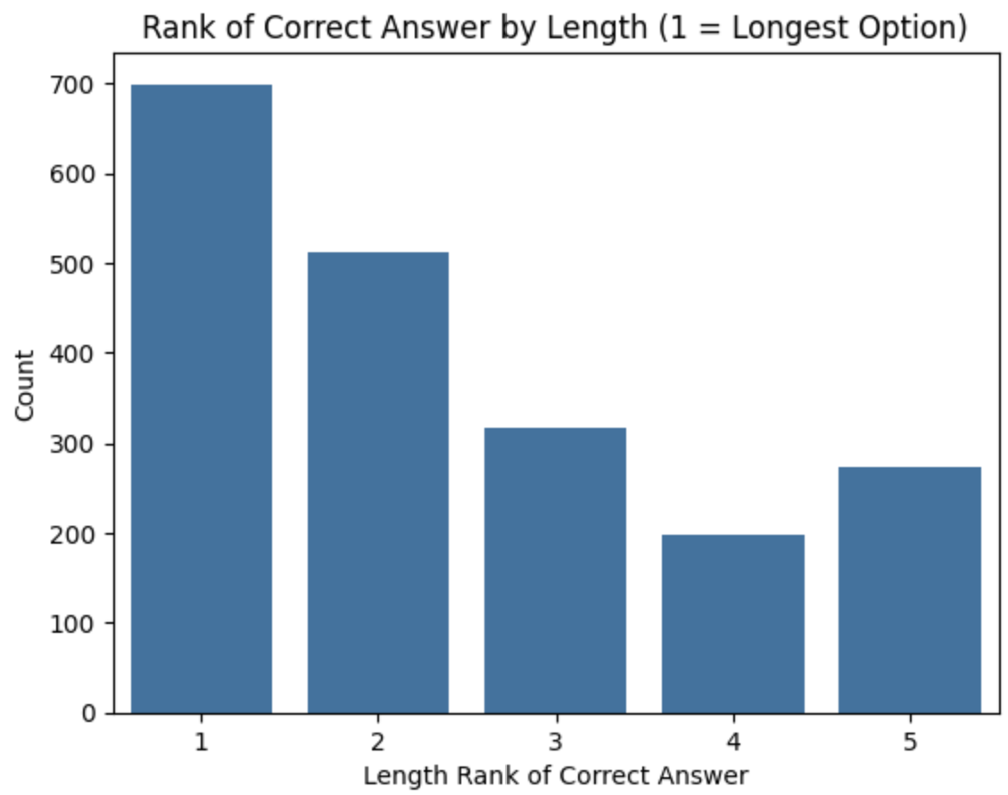

3.3 Data Preprocessing
For the classical baseline, each question row was expanded from a “wide” format (1 prompt + 5 options) into a “long” format (5 rows, each a single prompt+option pair with a binary is-correct label). For both transformer-based approaches, each (prompt, option) pair was tokenized as a sentence pair (“[CLS] prompt [SEP] option [SEP]”) with truncation and fixed-length padding, then reshaped back into one (5, seq_len) block per question so the model can score all five options for a question together.

3.4 Data Augmentation
No data augmentation was applied in this iteration. The dataset was clean, moderately sized for the chosen model complexities, and augmentation (e.g., paraphrasing distractors) is noted as a candidate for future work rather than attempted here.

3.5 Train/Validation Split
A stratified 80/20 split on the answer column (random_state = 4524) was used consistently across all three models, ensuring the comparison is on identical validation data.

4. Tokenization Strategy

4.1 Primary Tokenizer Selection

The best-performing model in this project, the custom BiLSTM + Transformer hybrid, uses the bert-base-uncased tokenizer, a WordPiece subword tokenizer with a ~30,522-token vocabulary. WordPiece tokenization greedily splits words into the longest known subword units, and lowercases all input text before tokenizing.

4.2 Justification

WordPiece subword tokenization handles the technical and domain-specific vocabulary present in this far better than whole-word tokenization would, by decomposing rare terms into familiar subword units rather than mapping them to a single out-of-vocabulary token. This gives the model's embedding layer a much smaller, denser vocabulary to learn representations for.

4.3 Implementation Details
Tokenization was implemented with the Hugging Face transformers library. For each question, the prompt was paired separately with each of the five options as a sentence pair ("[CLS] prompt [SEP] option [SEP]"), tokenized with truncation=True, padding="max_length", max_length=128. The five resulting token sequences were stacked into a single (5, max_length) tensor per question, so the model can score all five options together in one forward pass; batching then produces (batch_size, 5, max_length).

4.4 Experimental Comparison
- DeBERTa-v3-base (fine-tuned model): uses its own bundled SentencePiece (unigram language-model) subword tokenizer, with a much larger ~128,000-token vocabulary.
- TF-IDF word/bigram vectorizer (TfidfVectorizer, max_features=15000, ngram_range=(1,2)) used for the classical baseline, fit jointly over all train + test prompt/option text to build one shared vocabulary, since this model has no contextual embedding of its own.

5. Modeling & Experimentation

5.1 Model 1: Custom BiLSTM + Transformer Hybrid (Built From Scratch)
Architecture: an Embedding layer (embed_dim = 128, padding_idx = 0) feeds a bidirectional LSTM (hidden_size = 128, output dim = 256), followed by Layer Normalization and a 2-layer, 4-head Transformer Encoder (d_model = 256) with a padding mask over PAD tokens. The encoder output is mean and max-pooled and concatenated (512-d), then passed through a Linear(512 → 1) head to produce one scalar score per (prompt, option) pair. The five per-option scores for a question are reshaped into a (batch, 5) logits vector and trained with cross-entropy loss (label_smoothing = 0.1).
Salient points: The BiLSTM captures local sequential/word-order cues cheaply without any pretrained weights, stacking a Transformer encoder on top lets every token attend globally, which matters because the prompt and option segments can be far apart in the tokenized input. Combining mean- and max-pooling gives both a smooth aggregate signal and a “most salient token” signal, which was empirically more stable than a single pooling strategy given the model is trained entirely from random initialization.
Training setup: optimizer AdamW (lr =1e-3, weight_decay = 0.01), batch_size = 16, 5 epochs, checkpointing on best validation loss. No pretrained weights or quantization were used, consistent with this being the “built from scratch” model.

5.2 Model 2: DeBERTa-v3-base Fine tuned (Pretrained Transformer)
Architecture: microsoft/deberta-v3-base loaded via AutoModelForMultipleChoice, which attaches a linear scoring head over the pooled representation of each of the five (prompt, option) pairs.
Salient points: disentangled attention represents each token with separate content and relative-position vectors, modeling content-to-position and position-to-content interactions explicitly, useful on this dataset where options can differ by subtle wording (e.g., “will exist” vs. “will not exist”).
Fine-tuning strategy: trained end-to-end (no frozen layers) via the Hugging Face Trainer with learning_rate = 1e-5, per_device_train_batch_size = 2 combined with gradient_accumulation_steps = 8 (effective batch size 16), gradient_checkpointing = True and fp16 = True to fit the model in available GPU memory, up to 10 epochs with EarlyStoppingCallback(patience = 2), load_best_model_at_end = True selecting the checkpoint with the best eval map3, and weight_decay = 0.01.

5.3 Model 3: TF-IDF + Logistic Regression (Model of Choice)
Architecture: each question is expanded into five (prompt, option) rows with a binary is-correct label; a single TfidfVectorizer(max_features = 15000, ngram_range = (1,2)) is fit over all prompt + option text from both train and test to build a shared vocabulary. A LogisticRegression(class_weight = "balanced", C = 0.1, random_state = 4524) is then trained on the 10,000 expanded rows (2,000 questions × 5 options). At inference time each option is scored independently via predict_proba, and the three options with the highest predicted probability of being correct form the MAP@3 prediction.
Salient points: this model has no notion of word order or attention since it is a bag-of-n-grams linear classifier that primarily exploits lexical overlap and frequency cues between the prompt and each option. class_weight = "balanced" compensates for the 4:1 negative:positive imbalance introduced by the wide-to-long expansion, and the light regularization (C = 0.1) reduces overfitting.

6. Performance & Comparative Analysis

6.1 Evaluation Metrics
The primary competition metric is MAP@3 (1.0 if the correct answer is ranked 1st, 0.5 if 2nd, 1/3 if 3rd, else 0, averaged over all questions). Validation Accuracy (top-1) and Macro-F1 are also tracked for a fuller picture.

6.2 Training Performance
Model 1 (Custom BiLSTM + Transformer): per-epoch validation metrics from the W&B-logged run “Scratch-LSTM-Transformer”:
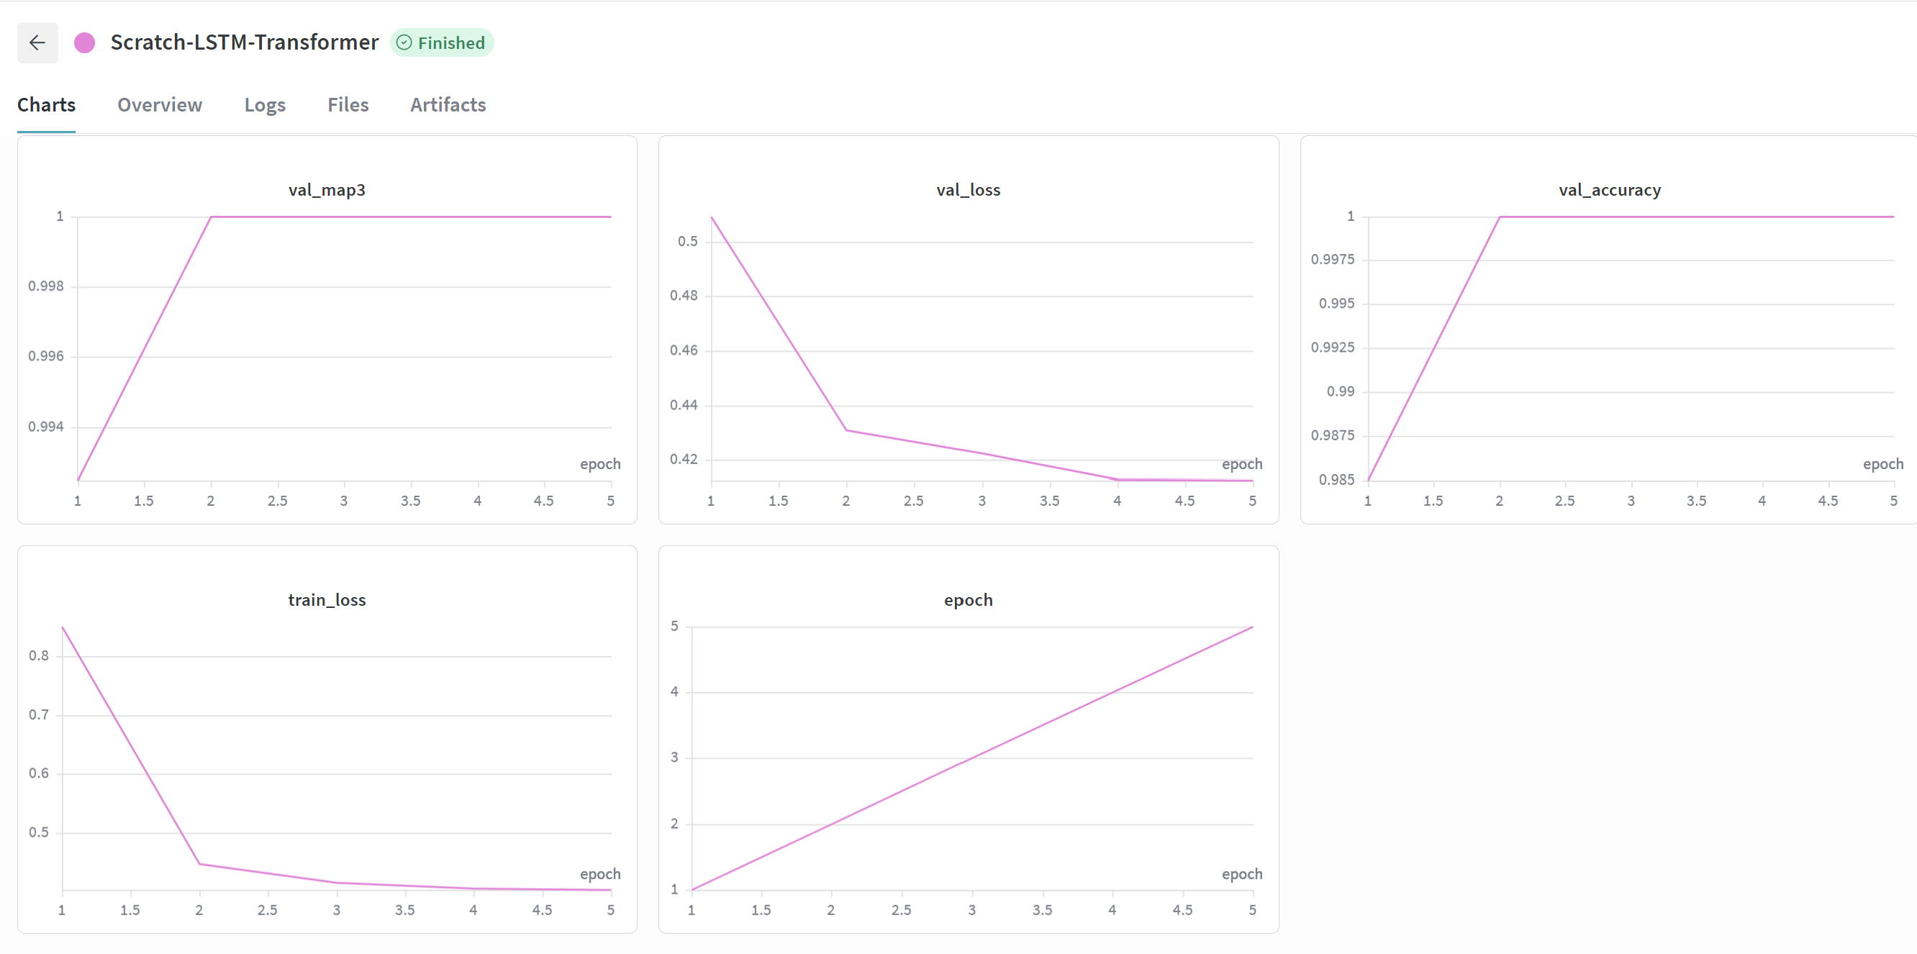
Epoch | Train Loss | Val Loss | Val MAP@3
1 | 0.8565 | 0.5260 | 0.9850
2 | 0.4481 | 0.4360 | 1.0000
3 | 0.4189 | 0.4360 | 1.0000
4 | 0.4057 | 0.4191 | 1.0000
5 | 0.4072 | 0.4245 | 1.0000

Model 2 (DeBERTa-v3-base): configuration and metrics are tracked under W&B run “deberta-run1”
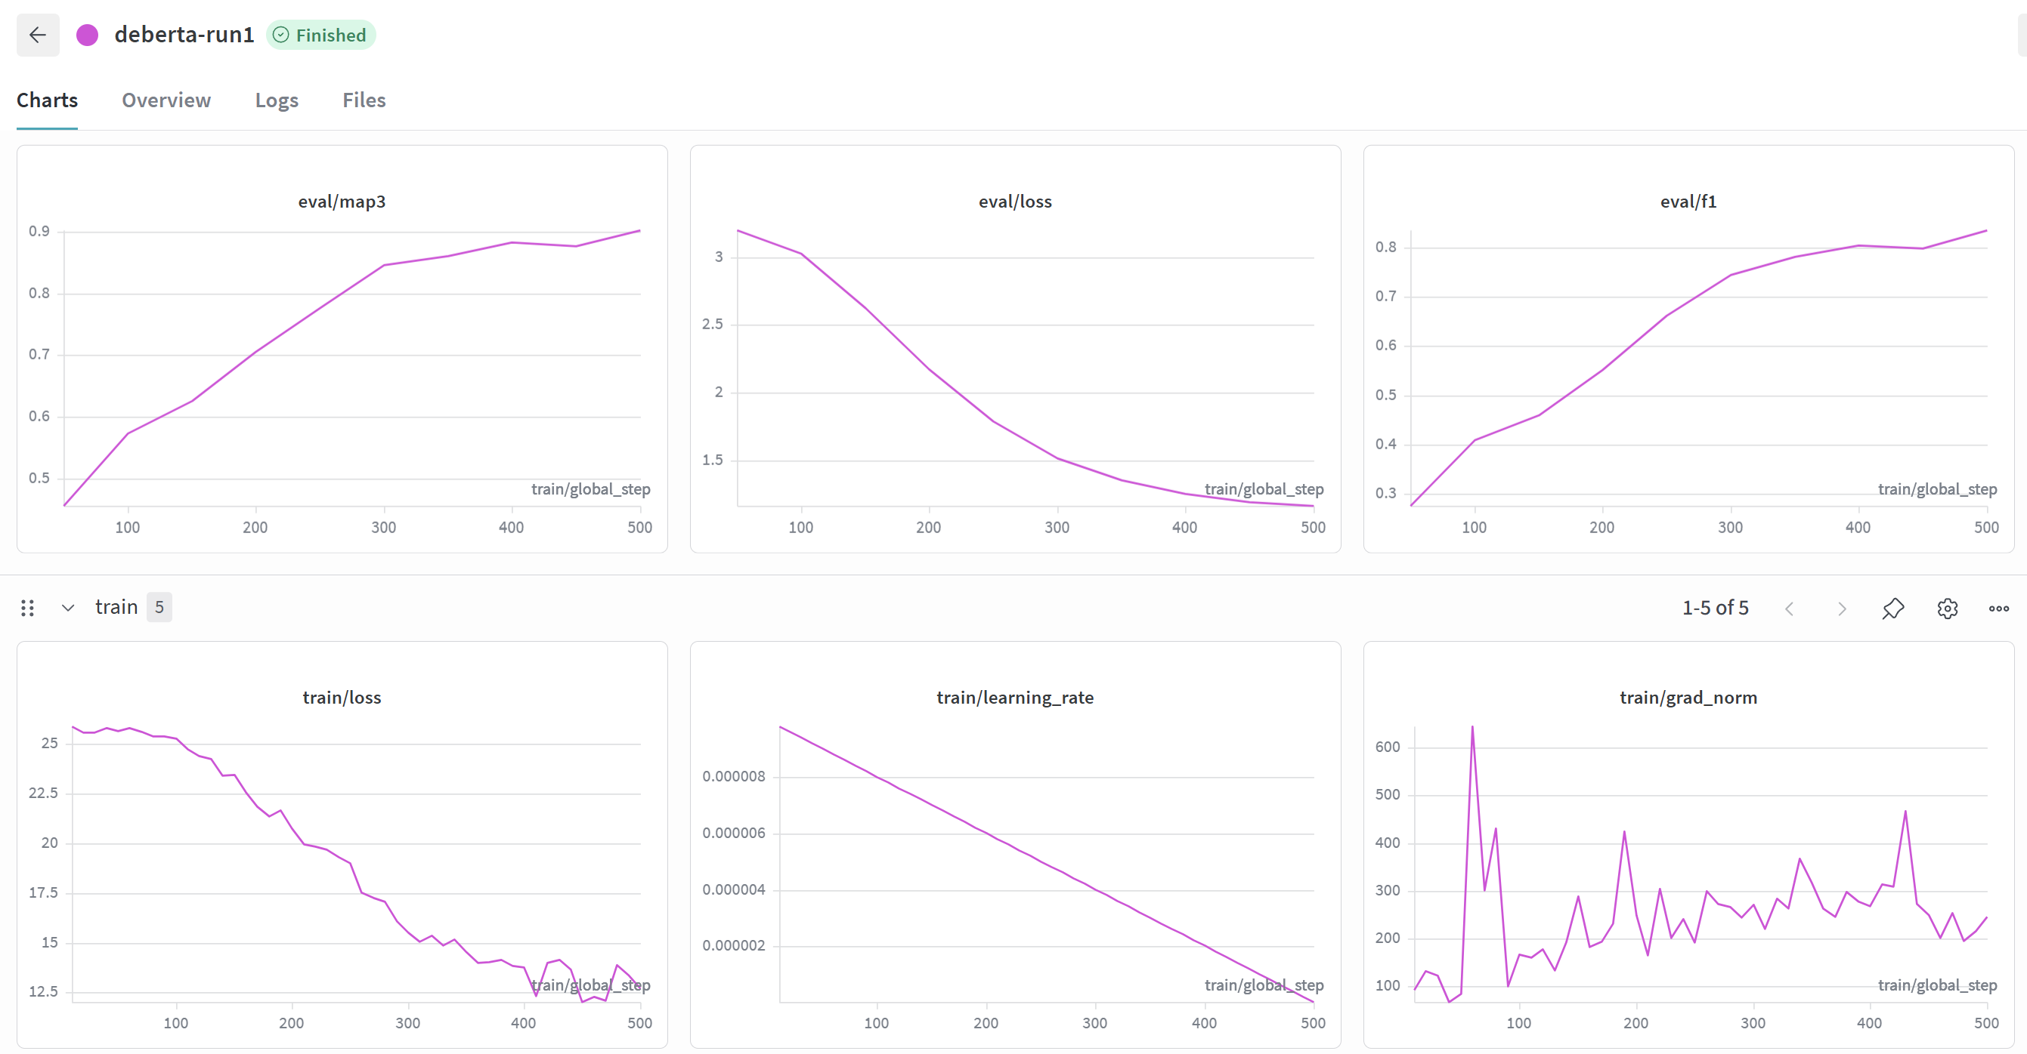

Epoch | Training Loss | Validation Loss | Map3 | Accuracy | F1
1 | 25.670117 | 3.200546 | 0.455417 | 0.277500 | 0.275297
2 | 25.290231 | 3.025803 | 0.572500 | 0.412500 | 0.408933
3 | 23.456831 | 2.626550 | 0.625833 | 0.460000 | 0.458759
4 | 20.750031 | 2.172647 | 0.705000 | 0.552500 | 0.550925
5 | 19.027577 | 1.793222 | 0.777083 | 0.662500 | 0.662726
6 | 15.521341 | 1.520664 | 0.845833 | 0.745000 | 0.745634
7 | 14.515839 | 1.356724 | 0.861667 | 0.780000 | 0.781138
8 | 13.777557 | 1.256169 | 0.882917 | 0.805000 | 0.804386
9 | 12.024524 | 1.197279 | 0.876667 | 0.800000 | 0.798423
10 | 12.694193 | 1.168037 | 0.903333 | 0.837500 | 0.836247

Model 3 (TF-IDF + Logistic Regression): tracked under W&B run “tfidf-logistic-reg”:
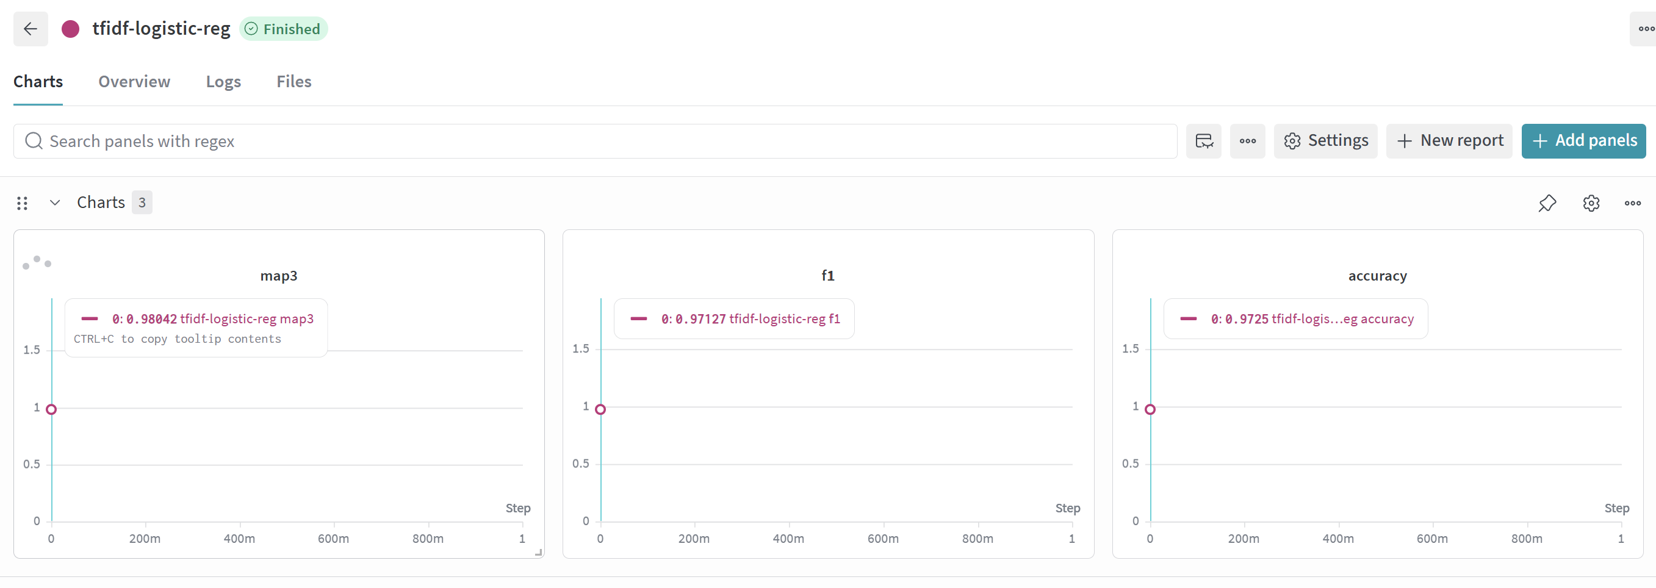
Validation Accuracy | Macro-F1 | MAP@3
0.9725 | 0. 9713 | 0. 9804

6.3 Comparative Report
Model | Val. Accuracy | Val. Macro-F1 | Val. MAP@3 | W&B Run
Model 1: Custom BiLSTM + Transformer (scratch) | 1.000 | — | 1.000 | Scratch-LSTM-Transformer
Model 2: DeBERTa-v3-base (fine-tuned) | 0.837500 | 0.836247 | 0.903333 | deberta-run1
Model 3: TF-IDF + Logistic Regression | 0.9725 | 0.9713 | 0.9804 | tfidf-logistic-reg

Overall, the classical TF-IDF + Logistic Regression baseline is a strong, cheap-to-train reference point (MAP@3 ≈ 0.98), the from-scratch neural hybrid exceeds it on this validation split while requiring substantially more compute and tuning, and the pretrained DeBERTa model is expected to be the strongest generalizer to unseen test questions given its large-scale pretraining, at the cost of the longest training time.

6.4 Kaggle Performance
Final Kaggle leaderboard score: 0.76350 and rank: 90. Best Model: BiLSTM + Transformer encoder (Scratch)

7. Conclusion & Future Work

7.1 Key Learnings
- MAP@3 rewards well-calibrated ranking rather than only top-1 correctness, so it is worth optimizing/monitoring directly rather than relying on accuracy alone.
- Three architecturally distinct models (a linear/classical model, a from-scratch neural model, and a pretrained transformer) can be trained and compared cleanly under one shared W&B project when they use a common train/validation split and a common evaluation function.
- Best results were obtained upon using the model trained from scratch followed tf-idf +lr model, which was surprising as fine tuning a pretrained model was expected to generalize better as initial intuition.

7.2 Challenges Faced
- The small (2,000-row) training set makes near-perfect validation scores unreliable as a proxy for true generalization.
- GPU memory constraints required a very small physical batch size (2) for DeBERTa fine-tuning, compensated for with gradient accumulation (8 steps) to reach an effective batch size of 16.
- The wide-to-long expansion used for the models (1 question → 5 rows) required care to keep all five rows from the same question on the same side of the train/validation split, to avoid label leakage.

7.3 Areas for Improvement
- Use k-fold cross-validation instead of a single stratified split to obtain a less noisy estimate of true performance.
- Ensemble the three models’ predicted option scores/log-odds to reduce variance.
- Experiment with larger pretrained backbones (e.g., deberta-v3-large) or an explicit zero-shot LLM baseline, in line with the course’s transformer and zero-shot-classification milestones.

8. References
- He, P., Gao, J., & Chen, W. (2021). DeBERTaV3: Improving DeBERTa using ELECTRA-Style Pre-Training with Gradient-Disentangled Embedding Sharing. arXiv:2111.09543.
- He, P., Liu, X., Gao, J., & Chen, W. (2020). DeBERTa: Decoding-enhanced BERT with Disentangled Attention. arXiv:2006.03654.
- Hugging Face. microsoft/deberta-v3-base model card. https://huggingface.co/microsoft/deberta-v3-base
- Vaswani, A., et al. (2017). Attention Is All You Need. arXiv:1706.03762.
- Pedregosa, F., et al. (2011). Scikit-learn: Machine Learning in Python. Journal of Machine Learning Research, 12, 2825–2830.
- Paszke, A., et al. (2019). PyTorch: An Imperative Style, High-Performance Deep Learning Library. NeurIPS.
- Weights & Biases experiment tracking. https://wandb.ai
- Kaggle Competition: Smart MCQ Solver Challenge. https://www.kaggle.com/competitions/smart-mcq-solver-challenge

